**Runner**

**24th January 2021**

# Kimberley Collins / LOGO

Confidential Disclaimer_________________________________________________________________

1. **Overview of the Game:**

The overview should be concise and impactful

* The genre of this game is going to be a running and jumping game which is going to be developed for computer devices. It is going to be a 2D platformer game.
* Basic Narrative
  + Throughout the game, the player is going to face obstacles, to avoid deducting the player’s health, the player needs to run away from the obstacles which they will consists of different strengths. If the player hit a coin, the score and the health bar will increase. At the end of the game, the game will show the player how much score does the player have.
* Inspirational References are Temple Run (2014) and Subway Surf (2012).
* Inspirational Art References are the below images

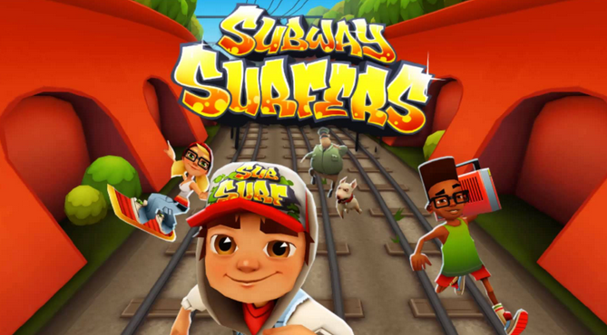

Figure2: Subway Surf (2012)

Figure1: Temple Run (2014)

## Game Loop

The game loop should thoroughly outline how your game is set up. You can be as concise or elaborate as you’d like, depending on the audience reading this -- is it a game publisher or your game studio leads. In any case, it’s helpful to provide a chart to accompany a written walkthrough of the player’s goals.

E.g. For an escape room game, the flow may simply look like this: 1) enter the room 2) explore the room and gather items 3) solve the puzzle 4) progress to the next room. Branch out from there, how many different characters or different environmental hazards change this loop; then expand on your loop.

Here’s just a few important questions to answer in this section. Be elaborative!

* 1. How long is the game?
  2. How many levels are there?
  3. What is the average play time?
  4. What are the objectives?
  5. How many playable characters? Can you customize or upgrade them/what can you customize or upgrade?
  6. How will the player move throughout the game? What is the locomotion style?

## Mechanics

What are the rules to the game, both implicit and explicit. This is the model of the universe that the game works under. Think of it as a simulation of a world, how do all the pieces interact? This actually can be a very large section.

* 1. Physics – How does the physical universe work?
  2. Movement in the game
  3. Objects – how to pick them up and move them
  4. Actions, including whatever switches and buttons are used, interacting with objects, and what means of communication are used
  5. Combat – If there is combat or even conflict, how is this specifically modeled?
  6. Economy – What is the economy of the game? How does it work?
  7. Screen Flow -- A graphical description of how each screen is related to every other and a description of the purpose of each screen.
  8. Game Options – What are the options and how do they affect game play and mechanics?

## Art Style & Assets

Include a description of your art style and supplement with art concepts or inspirational concepts.

Describe your style for the environment, characters, UI, etc. You can also link to a different area/scene it lives in.

## Player Profiles Stories

* Describe the ideal player profile or multiple profiles
* E.g. Sam loves to play narrative-driven games like Edith Finch….
* E.g. Alex is a completionist and likes to spend hours in a game purchasing or earning all the upgrades...
* How might these players play your game differently
* Walk the reader through your game loop and describe what your different player profiles focus on.

## Milestone Schedule

* Your Milestone Schedule should include the milestone #, milestone description, and date of delivery.
* The big milestones for your game include 1) Design 2) Look and feel 3) First Playable, 4) Final Game

## State Machine Diagram

* A UML Design that shows different game states and transitions.